How to convert .ui to .py

# Open Qt Designer:

1. Click on the Anaconda Prompt

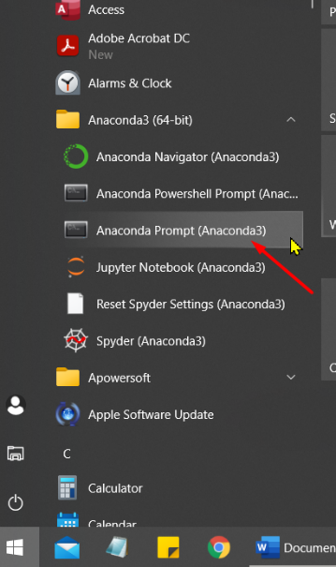

1. Type designer after C:\Users\Admin>

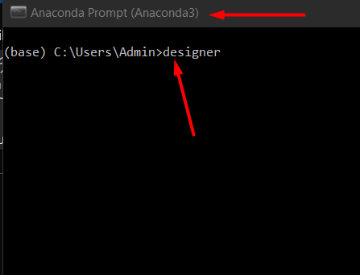

1. Be patient and after a while, you should see the Qt Designer pops up as in the following screenshot.

# Save the .ui File

1. Click on File-> New… (an New Form Window will pop up) Select Dialog without Buttons and Click on Create button at the bottom of the Window.

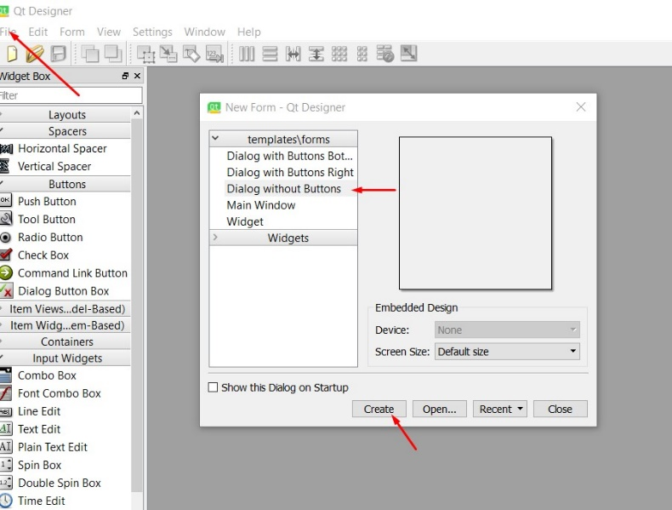

1. Drag and Drop a few Widgets to the Dialog/Form and Click on File->Save as…

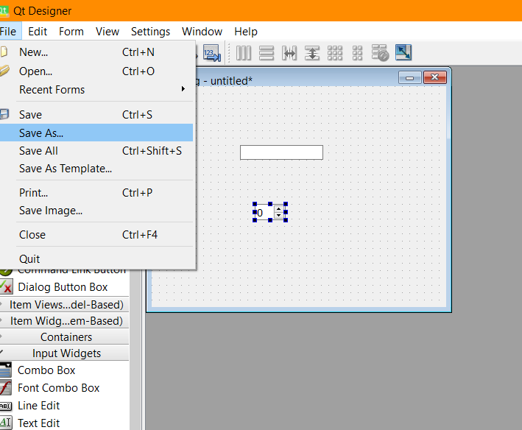

1. Select a location you want to keep all your .ui and .py files. Keep in mind that you will need to type this location in the command line before converting. e.g. I’ve created a folder called INF1511 in my A drive to store the file.

1. Open the Anaconda Prompt from Start menu. In Anaconda Prompt, type in command to the location of your saved .ui file. (e.g. First, I typed in **a:** to get to my drive a, and then **cd INF1511** to get the folder where I saved test.ui), type in **pyuic5 -x test.ui -o text.py** and press enter.

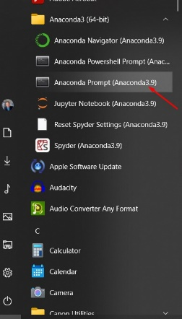 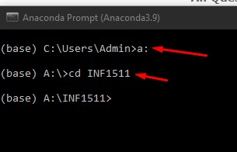 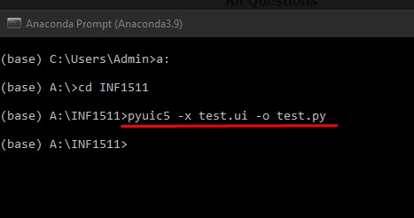

1. Go back to the folder, you should see an newly created file called test.py.